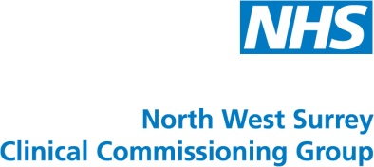
Are you feeling stressed, anxious or depressed?

You are not alone. One in four people experience a mental health problem every year.

Your local NHS provides a FREE service offering confidential advice and support. Providers offer a range of therapies in a sensitive and caring environment for those aged 18 years or over who are registered with a GP in North West Surrey:
- Spelthorne
- Runnymede
- West Elmbridge (Walton, Weybridge, Hersham)
- Woking
Organisation | Services offered | Get in touch | Clinic locations
Ieso Digital Health | One-to-one online therapy service using written (typed) conversation. | 01954 230 066  www.iesohealth.com/surrey  info@iesohealth.com | Online. Appointments available at a time to suit you, including evenings and weekends. You will need internet access and a tablet, PC or smartphone.
Healthy Minds | Complementary workshops, face-to-face consultations and over the telephone, or a combination of both. | 01483 698 986  healthyminds.surrey@nhs.net | Chertsey - Monday  Stanwell – Monday, Thursday & Friday  Walton – Thursday and Friday  Weybridge – Monday to Friday  Woking – Monday to Friday
Mind Matters | Workshops, face-to-face, telephone and online therapy sessions. | 0300 330 5450  www.mindmattersnhs.co.uk  RXX.surreyIAPT-referrals@nhs.net | Chertsey, Cobham, Weybridge and Woking
Talking Therapies Surrey Online | Online therapy service offering support 24/7 at a time that suits you. | 0300 365 2000  www.berkshirehealthcare.nhs.uk/surreyonline  bks-tr.surreytalkingtherapies@nhs.net | Online. Support you need from the comfort of your own home or whilst out and about. You will need internet access and a tablet, PC or smartphone.
Thinkaction | Face-to-face, group, one-to-one and telephone therapy sessions. | 01483 746 900  surreyptp@addaction.org.uk | Sheerwater, Staines, Weybridge and Woking

If you need help choosing a provider, you can ring First Steps on 0808 801 0325 or visit www.firststeps-surrey.nhs.uk

